(Approx. 503 words)
Creating Your Own Template in Word 2013
By Nancy DeMarte, 1st Vice President, Sarasota Technology User Group, FL
June 2015 issue, Sarasota Technology Monitor
www.thestug.org
ndemarte (at) Verizon.net

For many years, Microsoft Office has included templates. These are preformatted Word documents, PowerPoint presentations, or Excel spreadsheets, all ready for you to fill in the content. Using templates saves time and adds a professional look to a project. Office 2013 has changed a few things that make it easier for you to create your own templates.
Since installing Office 2013, I had used the Blank document template, which is the first one displayed in the gallery. Soon I had realized that I was not satisfied with some of the features of this template. I had wasted time by manually changing the line spacing and font too often. So I decided to create my own basic Word template. It was a lot simpler than I expected.
I didn’t begin with Blank document template because it contains the Normal style. I knew that some of my previously saved documents might be adversely affected if I did. Instead, I started by choosing the “Single spaced (blank)” template located near the Blank one in the gallery. It opened a box that showed its properties: Font: Calibri 11 point; Paragraph spacing: Single Space; Margins: 1” (on all sides). I clicked Create, and the template opened as a Document. Now I could make my changes. I kept Single Spacing, but chose the font, Calibri Light, in 14 point. To get slightly smaller margins, I clicked Page Layout – Margins, then Custom Margins. I adjusted the 1” margins to .8” on all sides and clicked “Set as Default” to save the margins setting.
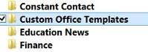
Then it was time to save this modified blank document as a template. I clicked File – Save As, opened the Documents folder, named the template “Nancy Single spaced Template,” changed the file type to “Word Template,” and clicked Save. When I opened the Documents folder, surprise! A “Custom Office Templates” folder had been created for me, and it held my new template. I later learned that this folder is created the first time you save any template in Word, Excel, or PowerPoint 2013 applications.
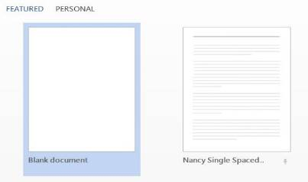
Even though I knew that this new template was stored in the Custom Office Templates folder, I was happy to see that it was also automatically listed in my PERSONAL templates area above Blank Document. And, when I restarted Word, it was also sitting next to the Blank document template, where I could easily choose it any time I opened Word.
You can create a template by modifying an existing one as I did. If you have a document that you use regularly, another option is to start with one of these documents and save it as a Word Template (.dotx). I currently have saved two customized Word templates and a custom PowerPoint template. I always name my personal templates to include the word “Template” so I can easily distinguish them from documents or presentations.

